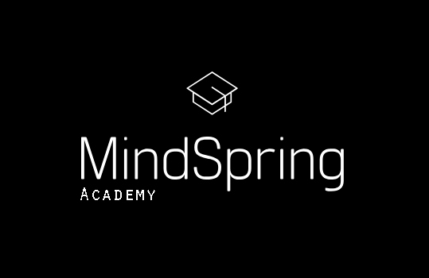

We provide an individual education plan tailored to each child’s specific needs teaching, tutoring or supporting their studies. Taught by fully qualified and practicing British teachers using the English National Curriculum Framework, we provide target setting, ongoing assessment, termly progress reporting as well as advising parents on how best to support their child’s progress at home.

MindSpring offers termly courses as well as Easter and Summer School to maximize your child’s learning potential.

Term 1
8th October – 18th December 2019

€330 per child per term (1hour per week until the 18th December)
€23 Registration Fee

Class Times

Tuesday 5:30pm – 6:30pm

Tuesday 6:30pm – 7:30pm

Thursday 5:30pm – 6:30pm

Thursday 6:30pm – 7:30pm

IBAN | ES84 0081 0012 1200 0193 5403
Reference | Child’s Name

Limited spaces!!
Payments termly in advance

